Empowering Database Efficiency: Navigating MaxScale GUI's Transformative Features

**By Miriam Figueroa, MSc**

Table of Contents

Meet the Expert: Author's Professional Credentials 3

Introduction 4

Purpose of the MaxScale GUI 4

Target Audience 4

Prerequisites for Installing and Configuring MaxScale GUI 5

Step-by-Step Installation Guide for MaxScale GUI 5

*Initial Configuration Settings for MaxScale GUI* 6

Understanding the Dashboard 7

Configuring Database Servers 8

Accessing Server Configuration 8

Specifying Server Parameters 10

Managing Services and Listeners 10

Monitoring manual Failover Events in MaxScale GUI 12

User Management and Security Settings 14

Steps to Generate ERD Using MaxScale 15

Importance and Usage of ERD in Database Management 17

Querying the Database Through MaxScale GUI 18

Troubleshooting and Common Issues 20

Common Issues and Their Solutions 20

Tips for Effective Troubleshooting 22

Monitoring Server Status and Performance 22

Conclusion 23

References 24

# Meet the Expert: Author's Professional Credentials

*Miriam Figueroa is a luminary in database administration, her expertise cemented by years of direct experience in the field and academic rigor. With a Master’s degree in Computer Science from Florida Atlantic University, her educational background provides a strong foundation for her technical prowess and innovative approach to database management. Specializing in the configuration, implementation, and management of MariaDB Galera Clusters and MaxScale for a diverse array of clients, Miriam’s practical knowledge is both deep and broad, covering the setup and management of over a hundred MariaDB servers and the intricate process of upgrading and configuring replication systems. This extensive experience, combined with a forward-looking perspective gained from confronting and overcoming real-world challenges, infuses this guide with invaluable insights and recommendations. Miriam’s credentials are further highlighted by her certifications, including Microsoft Certified Azure Administrator Associate, Azure Data Engineer Associate, Azure Database Administrator Associate, and Azure Solutions Architect Expert, showcasing her commitment to mastering the latest technologies in database management. Her journey, punctuated by a relentless pursuit of excellence and a passion for sharing knowledge, makes her not just an expert but a trusted guide in the ever-evolving landscape of database administration.*

# Introduction

Welcome to the official documentation for the MaxScale Graphical User Interface (GUI). This document serves as a comprehensive guide, designed to provide users with detailed insights and instructions on utilizing the full capabilities of the MaxScale GUI. The MaxScale GUI offers a user-friendly and intuitive interface, allowing for efficient management and monitoring of your MaxScale database proxies, ensuring optimal performance and reliability of your database systems.

# Purpose of the MaxScale GUI

The MaxScale GUI is engineered to simplify database administration and management complexities. It provides a visual interface for configuring, managing, and monitoring your MaxScale instances. With real-time analytics, detailed operational logs, and easy-to-navigate configurations, the MaxScale GUI is an indispensable tool for enhancing the performance and scalability of your database infrastructure. Whether you are looking to efficiently route database traffic, implement robust security measures, or monitor database operations, the MaxScale GUI equips you with the tools necessary to achieve these objectives precisely and easily.

# Target Audience

This documentation is tailored for a wide range of users, from database administrators and system architects to developers and IT professionals involved in managing and optimizing database environments. Whether you are a seasoned expert in database administration or new to MaxScale, this guide will walk you through every feature and functionality of the MaxScale GUI, ensuring a smooth and productive user experience.

# Prerequisites for Installing and Configuring MaxScale GUI

Before proceeding with the installation and configuration of the MaxScale GUI, ensure the following prerequisites are met:

MaxScale Installation: Confirm that MaxScale is properly installed and running. The GUI is a management interface for MaxScale, and its functionality depends on the underlying MaxScale service.

Web Browser: Have a modern web browser installed. The MaxScale GUI is accessed via a web interface, and using an updated browser ensures compatibility and security.

Network Accessibility: Ensure that the network configuration allows access to the MaxScale server's IP address and port. This might involve configuring firewalls or security groups to allow HTTP or HTTPS traffic.

User Credentials: Have the necessary MaxScale user credentials ready. Access to the GUI is controlled by MaxScale user accounts to ensure secure management.

# Step-by-Step Installation Guide for MaxScale GUI

Typically, the MaxScale GUI doesn't require a separate installation as it is a part of the MaxScale server package. Follow these steps to access and set up the MaxScale GUI:

Verify MaxScale Service: Ensure the MaxScale service is up and running on your server.

systemctl status maxscale

Access the GUI: Open your web browser and navigate to the MaxScale GUI using the server's IP address and the specific port designated for the GUI.

http://[MaxScale-Server-IP]:[GUI-Port]

Secure Connection (Optional): If your setup uses HTTPS for a secure connection, ensure you have the SSL/TLS certificates configured on the MaxScale server. Access the GUI using https in the URL.

https://[MaxScale-Server-IP]:[GUI-Port]

# Initial Configuration Settings for MaxScale GUI

Upon accessing the MaxScale GUI for the first time, you'll need to configure it to suit your environment:

Login: Use your MaxScale credentials to log into the GUI. These credentials are crucial for maintaining the security of your MaxScale administration.

Fig. Welcome screen.

Explore the Interface: Familiarize yourself with the GUI layout. The interface typically includes a dashboard, server view, services view, and user account management.

Configure Servers and Services: Use the GUI to add, remove, or modify your database servers and services. This includes setting up load balancers, routers, and listeners.

Set Monitoring Options: Configure monitoring and logging settings according to your operational requirements. This ensures you have the necessary insights and audit trails for your MaxScale environment.

Save Configurations: After making changes, ensure to save your configurations. Some changes might require a restart of the MaxScale service to take effect.

# Understanding the Dashboard

The MaxScale GUI Dashboard is your central hub for monitoring and managing your database infrastructure. It provides a comprehensive overview of your system's health and performance. Key components include server status indicators, service statuses, and connection statistics, allowing for real-time assessment of your database environment. Navigate through the dashboard to access detailed information on each component, ensuring efficient management and quick troubleshooting. The intuitive layout and interactive elements of the dashboard make monitoring your database operations both straightforward and effective.

Fig 2. Maxscale GUI dashboard.

# Configuring Database Servers

## Accessing Server Configuration

Navigate to Servers: Within the MaxScale GUI, locate the 'Servers' section. This is often accessible from the main dashboard or through a navigation menu.

Add New Server: Click on the option to 'Add Server' or 'Create New Server'. This action will prompt you to enter server details.

Alternatively, you can configure through the maxcale.cnf configuration. Below and snippet of the configuration.

**[maxscale]**

threads=auto

skip_name_resolve=yes

local_address=0.0.0.0

# Server definitions

**[dbserver1]**

type=server

address=<ip address>

port=3306

protocol=MariaDBBackend

priority=1

**[dbserver2]**

type=server

address=<ip address>

port=3306

protocol=MariaDBBackend

priority=2

**[dbserver3]**

type=server

address=<ip address>

port=3306

protocol=MariaDBBackend

priority=3

# Monitor for the servers

**[Galera-Monitor]**

type=monitor

module=galeramon

servers=dbserver1,dbserver2,dbserver3

user=monitor_user

password=<your-password>

monitor_interval=2s

use_priority=true

available_when_donor=true

disable_master_failback=true

backend_connect_timeout=3s

backend_write_timeout=3s

backend_read_timeout=3s

**# Service definitions**

**[Read-Only-Service]**

type=service

router=readconnroute

servers=dbserver2,dbserver3

user=maxscale

password=<your-password>

router_options=master,slave,synced

**#Galera Router Service**

**[Galera-Service]**

type=service

router=readwritesplit

servers=dbserver1,dbserver2,dbserver3

user=maxscale

password=<your-password>

master_reconnection=true

transaction_replay=true

transaction_replay_retry_on_deadlock=true

master_failure_mode=error_on_write

slave_selection_criteria=ADAPTIVE_ROUTING

Fig 3. Snippet maxscale.cnf configuration

## Specifying Server Parameters

Enter Server Details: Input the server's IP address and port number. These are essential for MaxScale to establish a connection with the server.

Assign Roles and Monitor Settings: Select the server's role from the available options (e.g., Master, Slave, Read-Only). Define monitoring settings appropriate to the server's role and your database topology.

Configure Server Options: Set other server options as needed, such as weight for load balancing, connection timeouts, and maintenance mode settings.

Save Configurations: After entering all details and configurations, save your changes. MaxScale may require a restart for the changes to take effect, depending on the nature of your configuration.

Verify Server Connection: Ensure that the newly added server is connected and configured correctly. Check for any error messages and confirm the server status is as expected.

# Managing Services and Listeners

Managing services and listeners in the MaxScale GUI involves a few key steps to ensure efficient database traffic handling and connectivity.

Creating and Configuring Services: In the MaxScale GUI, navigate to the services section to create a new service. Here, you can define the service type, which could include router options like read/write splitting. Configure the service by setting routing and load balancing rules, which are crucial for optimizing database query responses and managing traffic effectively.

Adding Listeners: After defining a service, you need to add listeners to it. Listeners are responsible for accepting incoming connections for that service. Specify the necessary parameters such as listener port and network interface.

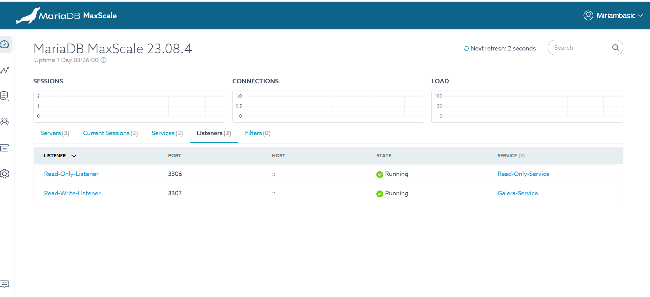

Fig 4. Listener configuration and status.

Activating Services and Listeners: Once configured, activate the services and listeners. This step is crucial to enable the handling of client requests and database connections according to the defined configurations.

Monitoring and Adjustments: Regularly monitor the performance of your services and listeners via the GUI. Make adjustments as necessary to accommodate changing traffic patterns or database demands.

This process streamlines service management in MaxScale, ensuring that database requests are efficiently routed and handled.

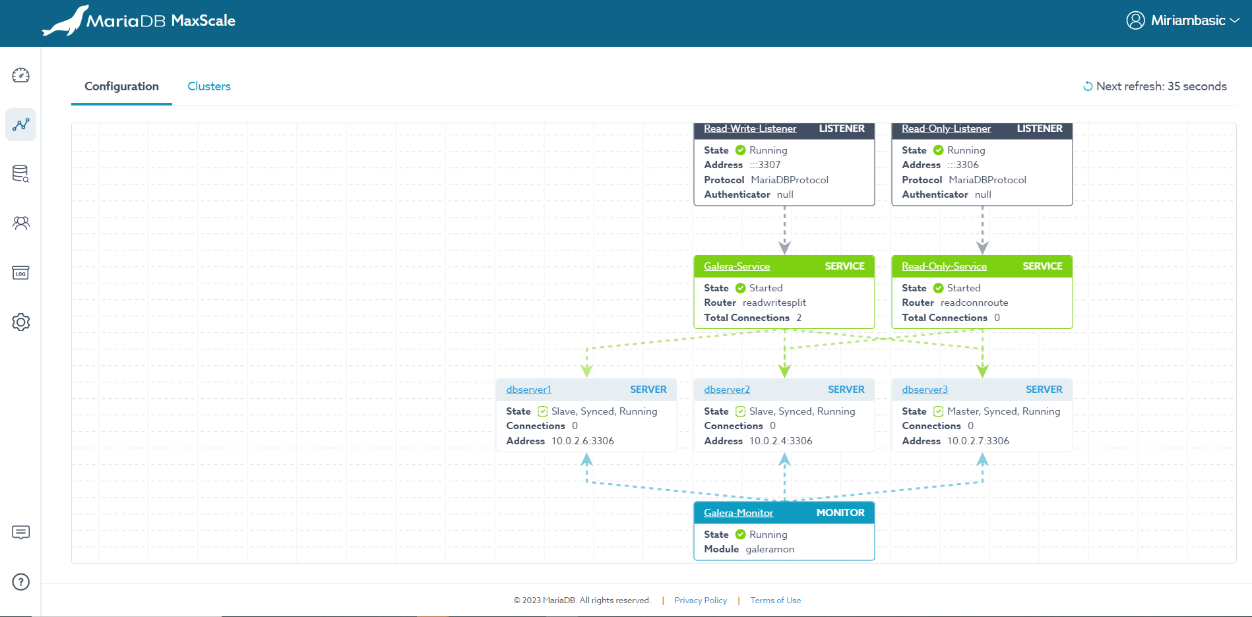

Fig 5. GUI representation of nodes, listeners and servers.

# Monitoring manual Failover Events in MaxScale GUI

When a failover is triggered from the MySQL shell, the MaxScale GUI effectively reflects these changes. This section documents how to monitor such events and acknowledges the possibility of initiating failovers directly from the GUI.

1. Manual Failover via MySQL Shell: Describe the process of triggering a failover for a node using MySQL shell commands. This action simulates a scenario where a node becomes unhealthy or goes offline.

Fig. 6 MySQL Shell shutdown of one of the nodes.

1. GUI Reflection of Failover: Once the failover is executed in the MySQL shell,

the MaxScale GUI immediately updates to show the changed status of the node, shifting from 'Healthy' to 'Unhealthy'.

Fig 7. Unhealthy node status.

1. Real-Time Status Updates: The GUI provides real-time updates on the
2. 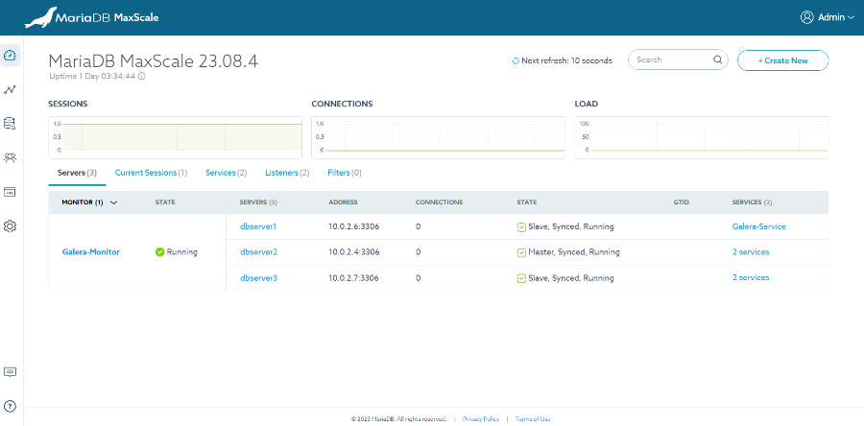 health status of each node using clear visual indicators, helping administrators to quickly identify and address issues.

Fig 8. Dashboard showing all nodes healthy.

1. 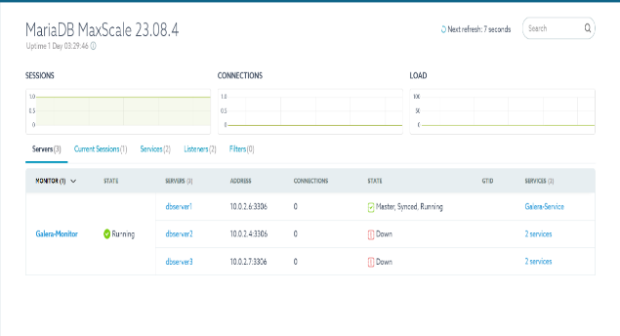Proactive Management: With these insights, database administrators can promptly respond to failover events, ensuring minimal disruption and maintaining the integrity of the database environment.

Fig 9. Dashboard updated with the nodes down.

This example highlights the responsiveness of the MaxScale GUI to changes made directly in the database environment, underlining its utility in high-availability scenarios.

# User Management and Security Settings

The User Management and Security Settings section in the MaxScale GUI is crucial for maintaining the security and integrity of your database environment. This section will detail how to manage user accounts, set up access controls, and configure SSL/TLS for secure connections based on the snapshots provided.

Figure 10. Users connected on the current session.

Creating and Managing User Accounts: In the MaxScale GUI, navigate to the user management section. Here, you can create new user accounts by specifying usernames, passwords, and roles. Roles define the level of access and permissions each user has.

Setting Up Access Controls: Access control in MaxScale can be configured to restrict or allow user access based on various criteria such as IP addresses, usernames, or time of access. This is vital for protecting sensitive data and ensuring that only authorized users can access certain functions.

Configuring SSL/TLS Settings: To secure connections to the MaxScale GUI and database servers, SSL/TLS settings should be configured. This involves specifying the paths to the SSL certificate files and enabling SSL in the connection settings. Secure connections help protect data in transit from eavesdropping or tampering.

Monitoring User Activities: The GUI also provides functionality to monitor user activities, allowing administrators to track who accessed what and when adding an additional layer of security through transparency.

Figure 11. Lists of users running on the server.

# Steps to Generate ERD Using MaxScale

An Entity Relationship Diagram (ERD) is a crucial tool in database management, providing a graphical representation of the database structure. This diagram helps in understanding the relationships between different data entities and is instrumental in designing, managing, and modifying a database. MaxScale offers capabilities to assist in generating ERDs, facilitating a deeper understanding of the underlying database architecture.

Access the ERD Generation Tool: Navigate to the ERD generation feature in the MaxScale GUI. This might be in a tools or utilities section, depending on your version of MaxScale.

Select the Database Schema: Choose the database schema for which you wish to generate the ERD. MaxScale will analyze the schema to identify tables, columns, keys, and relationships.

Fig 12. Selecting the database nation for visualization of the ERD diagram.

Configure ERD Options: Depending on the complexity of your database, you may have options to customize the ERD. This can include choosing which relationships to display, filtering specific tables, or adjusting the layout of the diagram.

Generate the ERD: Once you have selected the schema and configured your options, initiate the ERD generation. MaxScale will process the schema and create the diagram.

Review and Export the ERD: After the ERD is generated, review it for accuracy and completeness. You can then export the ERD to various formats such as PDF or PNG for documentation purposes or further analysis.

Fig. 13 Nation ERD diagram generated by the tool.

# Importance and Usage of ERD in Database Management

ERDs are fundamental in database management for several reasons:

Database Design and Planning: ERDs are used extensively during the initial design phase of a database. They help in visualizing the structure of the database, making it easier to plan and implement an efficient database schema.

Understanding Relationships: ERDs vividly illustrate how different tables and fields are interrelated. This understanding is vital for optimizing queries and ensuring data integrity.

Documentation and Communication: ERDs serve as a valuable documentation tool. They provide a clear and concise way to communicate the database structure to both technical and non-technical stakeholders.

Troubleshooting and Refactoring: When modifying or troubleshooting a database, ERDs can help identify where changes should be made and how those changes will impact other parts of the database.

# Querying the Database Through MaxScale GUI

The MaxScale GUI provides a streamlined interface for querying your database. To issue queries through the MaxScale GUI, follow these general steps:

Connect to the Database: Access the query interface in the MaxScale GUI. Enter the database credentials (username and password) to establish a connection to your desired database.

Fig 14 Connecting to the database to issue queries against the database.

Issue Queries: Once connected, you can write and execute SQL queries directly through the GUI. The interface typically provides a query editor where you can input your SQL commands.

Fig 15. Query results and information of the database.

View Results: After executing your queries, the results will be displayed within the GUI. You can review the returned data, errors, or messages directly in the interface.

Manage Sessions: The GUI allows you to manage your query sessions effectively, including closing the connection after your query operations are complete.

Fig 16,17 Getting query stats from the dashboard

# Troubleshooting and Common Issues

Effective troubleshooting is key to maintaining the smooth operation of your MaxScale environment. This section outlines common issues encountered in MaxScale and provides tips for efficient troubleshooting.

### Common Issues and Their Solutions

Connection Issues: If clients cannot connect to MaxScale, check firewall settings, ensure MaxScale services are running, and verify network configurations.

Fig 17. Stats of the parameters of the server based on the execution of the queries.

Fig 18, 19 Diagram and status of the servers. With all databases nodes down.

Certificate Errors: SSL/TLS-related issues often stem from incorrect certificate configurations. Verify the paths to your certificate files and ensure they are up to date and valid.

Performance Bottlenecks: If you encounter performance issues, review query logs, monitor resource usage, and consider adjusting MaxScale's load balancing configurations.

Authentication Failures: Authentication problems can usually be resolved by verifying user credentials, checking database user settings, and ensuring that the authentication plugins are correctly configured in MaxScale.

## Tips for Effective Troubleshooting

Check Logs: MaxScale logs are invaluable when diagnosing issues. Review the logs for error messages or warnings.

Fig 20. Maxscale Logs

## Monitoring Server Status and Performance

Resource Monitoring: Monitor CPU, memory, and disk usage to identify resource-related issues that might be affecting MaxScale's performance.

View Server Status: In the 'Servers' section, observe the status indicators next to each server. These indicators often use color codes or icons to reflect the health and status of the server (online, offline, maintenance mode, etc.).

Review Performance Metrics: MaxScale GUI provides performance metrics such as query response times, number of connections, and throughput. Regularly review these metrics to assess server performance.

Respond to Issues: If a server is underperforming or encountering errors, use the GUI's tools to troubleshoot. This may include examining detailed logs, adjusting server configurations, or redistributing the load.

Configuration Validation: Ensure that your maxscale.cnf file is correctly formatted, and all configurations are set as intended.

Community and Support: Utilize the MaxScale community forums and official support channels for guidance and troubleshooting assistance.

# Conclusion

As we wrap up this comprehensive exploration of the MaxScale Graphical User Interface (GUI), it becomes evident that MaxScale stands not just as a tool, but as a pivotal ally in the realm of database management. Through its user-friendly interface, MaxScale GUI simplifies the complex intricacies of database administration, making powerful features accessible to administrators and IT professionals alike.

The journey from installation to advanced monitoring and troubleshooting reveals the GUI’s robust capability to enhance operational efficiency and database performance. By facilitating a deeper understanding of database architecture through ERDs, ensuring secure connections via SSL/TLS configurations, and allowing for real-time query execution and monitoring, MaxScale GUI empowers users to maintain high availability and optimal performance of database systems with ease and precision.

Moreover, the discussion on troubleshooting and common issues underscores the importance of effective problem-solving strategies in maintaining a seamless database environment. With MaxScale GUI, users are equipped not only with a tool for day-to-day management but also with a comprehensive solution for addressing challenges proactively, ensuring the integrity and reliability of database infrastructures.

In conclusion, the MaxScale GUI emerges as an indispensable instrument in the orchestration of database management. Its intuitive design, coupled with advanced features, positions MaxScale GUI as a catalyst for enhancing database operations, ensuring that administrators are well-equipped to navigate the complexities of modern database ecosystems. As we continue to navigate the evolving landscape of database technology, the MaxScale GUI stands as a testament to the innovation and efficiency that drive progress in database management.

This document, intended for a diverse audience of database professionals, encapsulates the essence of MaxScale GUI — a gateway to achieving unparalleled database efficiency and reliability. Embrace the transformative features of MaxScale GUI and unlock the full potential of your database systems, ensuring a robust, efficient, and secure database environment.

# References

For further learning and a deeper understanding of MaxScale and its functionalities, the following resources are highly recommended:

MaxScale Official Documentation:

* MariaDB MaxScale Documentation: [MariaDB MaxScale](https://mariadb.com/docs/server/service-management/admin-tools/maxscale/)

This comprehensive documentation covers all aspects of MaxScale, from installation and configuration to advanced features like load balancing, monitoring, and high availability.

* MariaDB Knowledge Base:

Visit MariaDB Knowledge Base for a vast repository of articles, user guides, and best practices on MariaDB and MaxScale.

* Community Support and Forums:

MariaDB Community: [MariaDB Community](https://mariadb.org/)

Engage with the MariaDB community for support, to share experiences, and to get insights from other MaxScale users.

* Webinars and Tutorials:

Explore webinars and tutorials on MaxScale provided by MariaDB experts to get hands-on experience and learn best practices.

* GitHub Repository for MaxScale:

MaxScale GitHub Repository: MaxScale GitHub

Access the source code, contribute to the project, and stay up-to-date with the latest developments in the MaxScale project.

These resources will provide you with a wealth of information and the support needed to effectively utilize MaxScale in your database environment.